**­­COMP1003: Maths Worksheet1**

**Basics**

This first maths worksheet is intended specifically for students who do **not** have A-level mathematics; it aims to remind you of some of the basics of mathematics that we’ll need each week. You should undertake this worksheet in the first maths practical. If you can’t finish them within an hour continue during the rest of the week. Solutions to these exercises will be posted on the DLE at the end of the week.

Before you come to the first maths practical you should have studied the MathsBasics lecture on the DLE.

Students who **do** have A-level maths should also go through the exercise; hope fully with no major problems.

This material is not assessed and you can – if you wish – work in groups; do also seek out advice from the tutor – but only once you’ve given it a go first.

For each question you should attempt to arrive at an answer to the question *via methodical step-by-step working*: it is very definitely not just about getting the final answer (and indeed some of the formal assessment that you’ll undertake later in the module will demand that you present your working). If you’ve worked in a group, each individual student should make sure they have a copy of their own working for future reference.

For future weeks I’d suggest that you read the lecture notes before you come to the lecture (it’ll be hard going – but it *will* help), and re-study them again before the practical. You could also have a look/go at the relevant exercises (available via the DLE) before the maths practical – again, no matter how little progress you make, it will help.

**1.** What is 2/3 when expressed as a decimal (rounded to 3 decimal places)?

a. 2.333

b. 5.000

c. 0.667

d. 0.750

e. 1.333

**2.** If x=2/3 what is the value x+1?

a. 4/3

b. 5/3

c. 3/2

d. 5/4

e. 3/3

**3.** If x=2/3 what is the value of 2*x? (2 times x)

a. 4/3

b. 4/6

c. 2/6

d. 2

e. 3

**4.** If x=2/3 and y=4/7, what is the value x+y?

a. 8/21

b. 8/7

c. 6/10

d. 26/21

e. 8/10

**5.** If x=2/3 and y=4/7, what is the value x*y? (x times y)

a. 8/21

b. 14/12

c. 12/14

d. 21/8

e. 26/21

**6.** If x=2/3 and y=4/7, what is the value x/y? (x divided by y)

a. 8/21

b. 7/6

c. 6/7

d. 21/8

e. 6/10

**7.** If x=3 and y=4, what is the value x*(y+2)?

**\*\*\*\*\***

If x is a number, then “x-squared” is denoted by x2 and equals x2 = x*x (x times x)

**8.** If x=3, what is the value of (x2 - 3)/2?

a. 9

b. 1.5

c. 3

d. 1

e. 2

*Distributivity* states that if a, b and c are numbers, then a(b+c) = ab + ac

**9.** Using distributivity, decide which of the following expressions is equal to x*(y+2x)

a. xy + x2

b. y + 2x2

c. xy + 2x2

d. x*y*2x

e. 3x2

Factoring is in some sense the opposite of distributivity: for example 21x+35y = 7*3x + 7*5y =

7(3x+5y). Here we have factored out the common factor (in this case 7).

**10.** Which of the following expressions is equal to 9xy + 3x2?

a. 12xy

b. 12yx2

c. 3x(3y+x)

d. 3x(y+x)

e. x(9y+3)

*****

For the purposes of this module, a *function* f takes each number x and produces a new number f(x). For example if f is defined by the equation f(x) = x2 then f(1) = 1; f(2) = 4; f(3) = 9; f(3.5) = 12.25 … etc, etc.

**11.** If f(x) = x2, what happens to the value of f as x gets larger and larger?

a. f gets larger and larger

b. f gets smaller and smaller

*****

If b = a2, then a is a square root of b. So for example 32 = 9, and therefore 3 is a square root of 9. (As an aside, -3 is also a square root of 9, but we won’t need to bother with “negative roots”.)

**12.** If x=64, what is the square root of x?

a. 8

b. 4

c. 16

d. 1

e. 2

******

If x is a number, then “x-cubed” is denoted by x3 and equals x3 = x*x*x (x times x times x)

**13.** If x=3, what is the value of x3 + 2x?

a. 27

b. 6

c. 35

d. 31

e. 56

**14.** If f(x) = 1/x, what happens to the value of f as x gets larger and larger?

a. f gets larger and larger

b. f gets smaller and smaller

**15.** What is 30% of 200?

a. 30

b. 100

c. 120

d. 60

e. 45

**16.** If 2x + 3y = 26, and x=4, what is the value of y?

a. y=1

b. y=3

c. y=5

d. y=7

e. y=6

**17.** If x2 + y2 = 25, and y=3, what is the value of x?

a. x=1

b. x=3

c. x=4

d. x=6

e. x=7

Given a function f, we can plot the graph (or curve) of f: for example if f(x) = x2 then the graph of y = f(x) is show below. (You can try out a few values and check it out.)

y

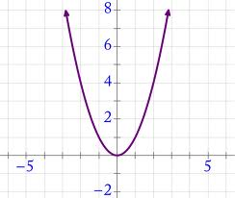

x

The slope of a curve y = f(x) is *positive* if the value of y increases as x increases. So for example the above curve has a negative slope when x<0 and a positive slope when x>0.

**18.** Is the slope of the graph below positive or negative?

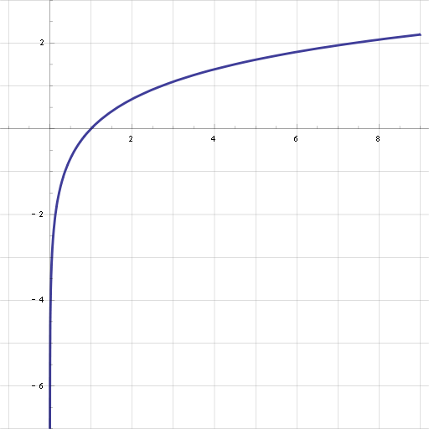

a. positive b. negative c. sometimes positive and sometimes negative

**19.** Is the slope of the graph below positive or negative?

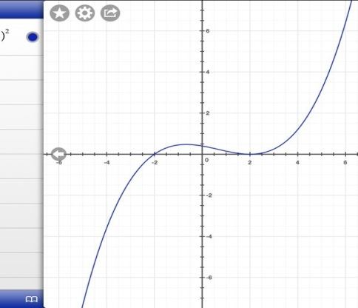

a. positive b. negative c. sometimes positive and sometimes negative